

A Synopsis on

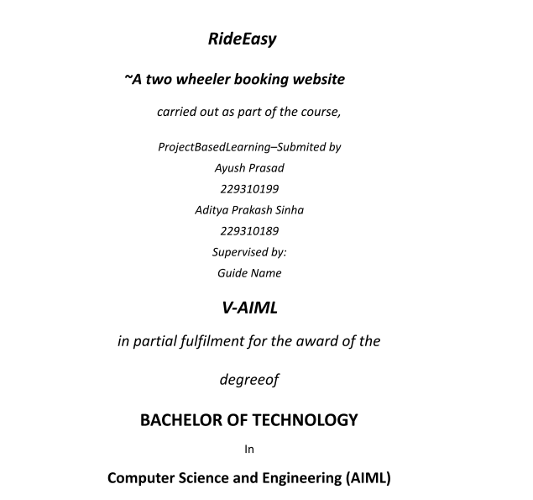**Easy2Ride**

**Department of Artificial Intelligence and Machine Learning**

**School of Computer Science & Engineering**

**Manipal University Jaipur,**

***August 2024***



# Introduction

In today’s fast-paced environment, time is of the essence, and convenience is a key factor in how we make decisions. Students and residents at Manipal University Jaipur often require two-wheelers for various purposes, such as commuting within the campus, exploring the city, or for leisure rides. The traditional method of renting two-wheelers involves physically visiting rental shops, negotiating prices, and dealing with ambiguous terms, which can be time-consuming and inconvenient.

To address these challenges, we are developing an online platform that allows users to browse, select, and book two-wheelers conveniently and securely. This website will provide a seamless experience, allowing users to reserve a vehicle from the comfort of their location, thereby saving time and avoiding the hassle of conventional booking methods.

# Objective

The primary objective of this project is to develop a user-friendly, secure, and efficient web platform that enables students and residents of Manipal University Jaipur to book two- wheelers online. The platform will focus on:

* + Providing a seamless browsing and booking experience.
  + Ensuring data security and privacy for all users.
  + Reducing the time and effort involved in renting a two-wheeler.
  + Offering transparency in pricing, availability, and terms of service.

# Technical Specifications

* Frontend Technology: React.js

* Styling: CSS3, TailwindCSS, or Bootstrap for styling and responsiveness. * Backend Technology: Express.js (Node.js Framework)

* Database: MongoDB (NoSQL Database) or MySQL (SQL Database)

Development Tools:

IDE: Visual Studio Code (VS Code)

Version Control: Git & GitHub for version control and collaboration.

# Modules and Sub-Modules

Module 1: User Management

1. Registration & Login:

User sign-up with email, password, and basic details. Secure login with JWT-based authentication.

Profile Management:

View and update profile information.

Manage saved payment methods and booking history.

Module 2: Vehicle Browsing & Selection

1. Vehicle Listing:

Display available two-wheelers with filters for type, brand, price, and availability. Search Functionality:

Search bar with keyword-based search and advanced filters.

1. Vehicle Details Page:

Detailed view of selected two-wheelers, including images, specifications, pricing, and availability.

Module 3: Booking Process

1. Date & Time Selection:

Users can select the start and end date/time for booking.

1. Pricing Calculation:

Dynamic calculation of rental cost based on the selected vehicle and duration.

1. Booking Confirmation:

Review of booking details and confirmation page. An SMS would be sent if the booking is confirmed.

Module 4: Payment Gateway Integration

1. Payment Methods:

Integration with popular payment gateways (e.g., PayPal, Stripe) to support credit/debit card transactions and UPI.

1. Transaction Security:

SSL encryption for secure payment transactions.

Module 5: Notifications & Communication

1. Email & SMS Notifications:

Automatic notifications for booking confirmation, reminders, and cancellations.

# Methodology and Proposed Diagram

# The development will employ Agile methodologies, ensuring iterative improvements and regular user feedback. Key technologies include React.js for the frontend, Express.js for the backend, and MongoDB/MySQL for the database.

# (Diagram showing system architecture and data flow)

# Expected Outcomes

# A fully functional, user-friendly two-wheeler rental platform.

# Increased user engagement and satisfaction through improved service delivery.

# Streamlined booking processes that reduce waiting times.

# Timeline

# Phase 1: Requirements Gathering (Month 1)

# Phase 2: Design and Prototyping (Month 2)

# Phase 3: Development (Months 3-5)

# Phase 4: Testing (Month 6)

# Phase 5: Deployment and Launch (Month 7)

# Conclusion

This proposal outlines the development of a two-wheeler booking website aimed at providing a streamlined and secure service to the students and staff of Manipal University Jaipur. The proposed platform leverages modern web technologies to deliver a user-centric experience, ensuring ease of use, security, and transparency throughout the booking process. With the outlined modules and technical specifications, this project aims to revolutionize the way two-wheelers are rented around the university campus, contributing to greater convenience and efficiency for all users.

